My last project dealt with KPI Management System based on a methodology called Balanced Score Card. The application was developed from scratch, all by myself, except some images, using :

* HTML, CSS, Bootstrap 4, Javascript, some Web APIs, ReactJs, React-Select, ag-Grid, Tabulator and several other javascript libraries at the front-end
* PHP and Laravel at the back-end
* MySQL for database

Here I attach several screenshots from the application :

1. This is a form that displays a list of what is called performance contract (KK) of every employee in an organization as well as its corresponding KPI manuals.

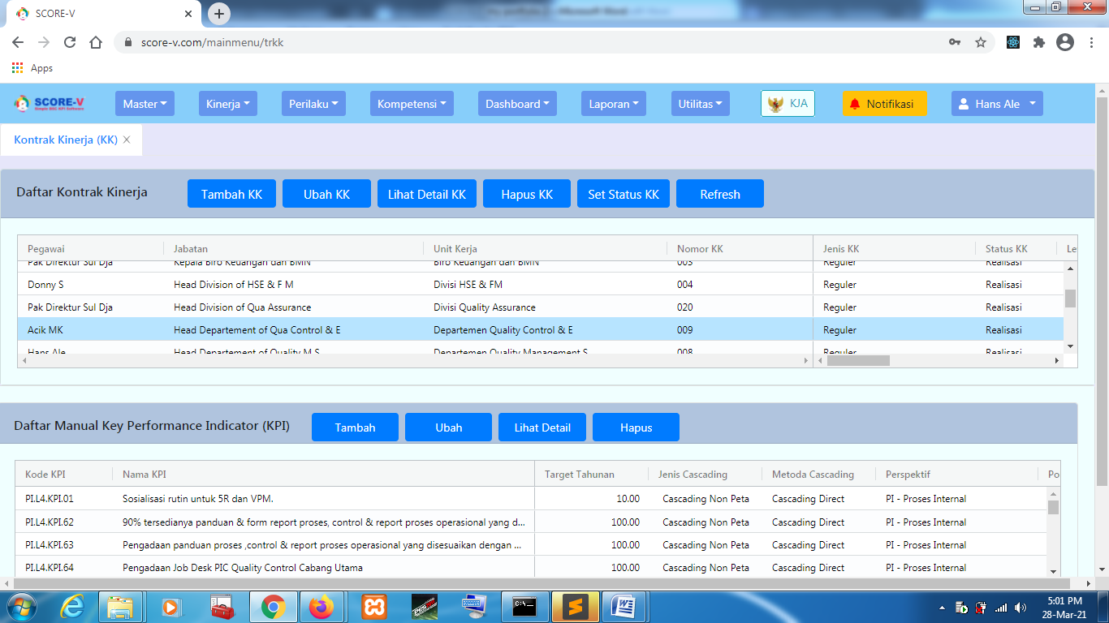

Figure

1. The next form deals with a phase called verification of every kpi manuals that have already had realization of corresponding target specified. As shown in the figure, this form is rendered in a new tab within the application, rather than in a new browser tab. This tab feature can be useful for users who want to open different forms in different tabs within the application. Each of these tabs is closable.

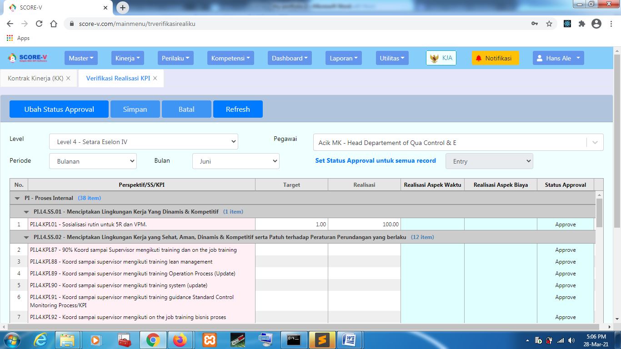

Figure

1. The next figure shows a dashboard which presents a performance achievement (score) of an employee. The dashboard is presented in a table (data grid) format as well as in a visualized format using gauges and charts.

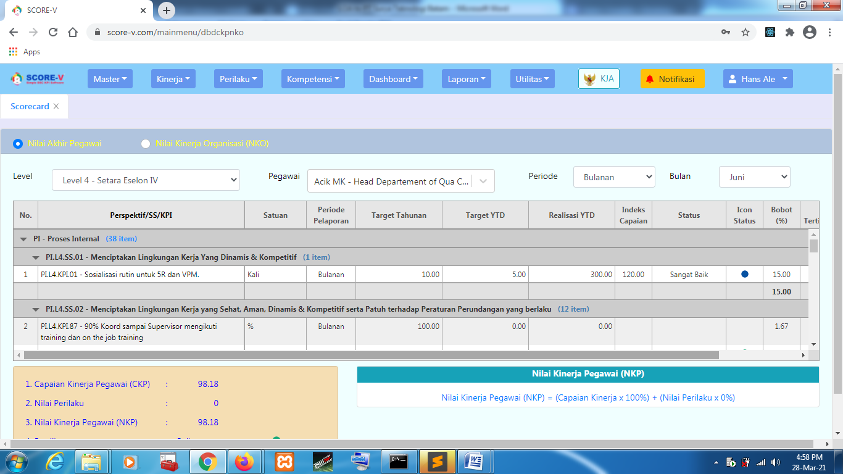

Figure

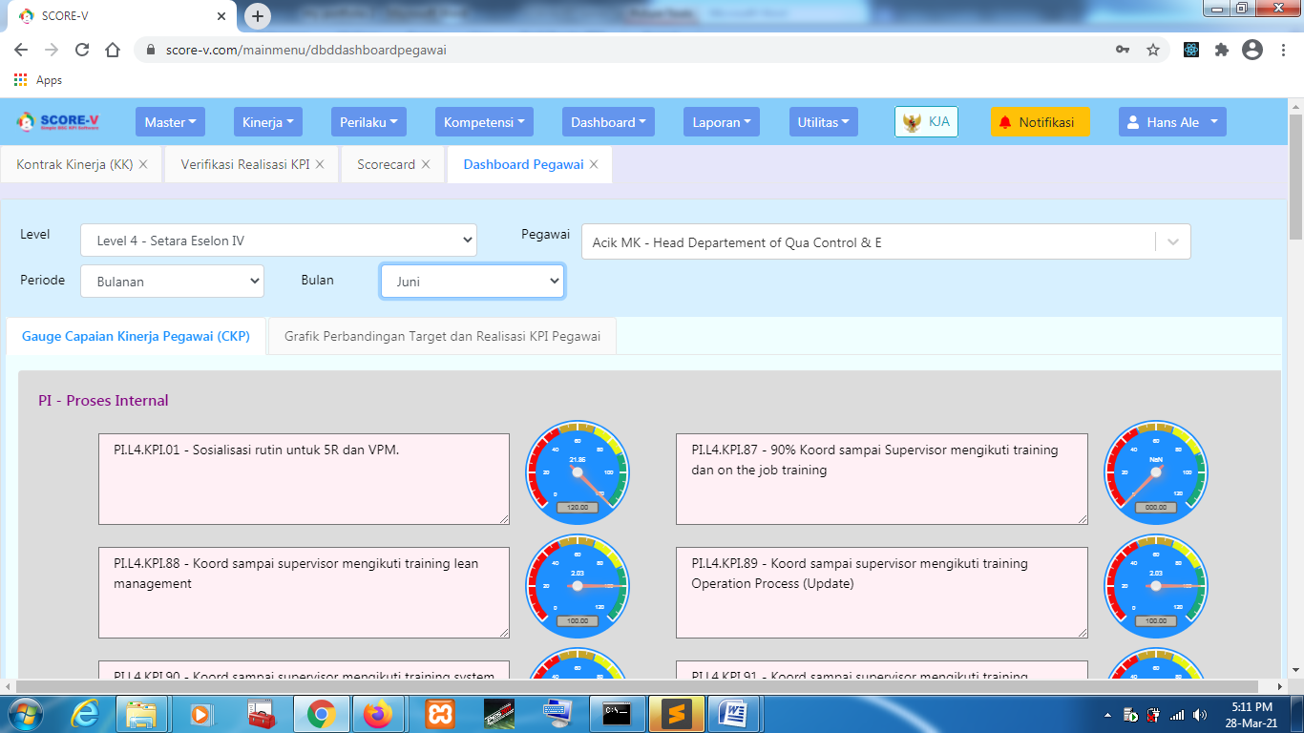

Figure

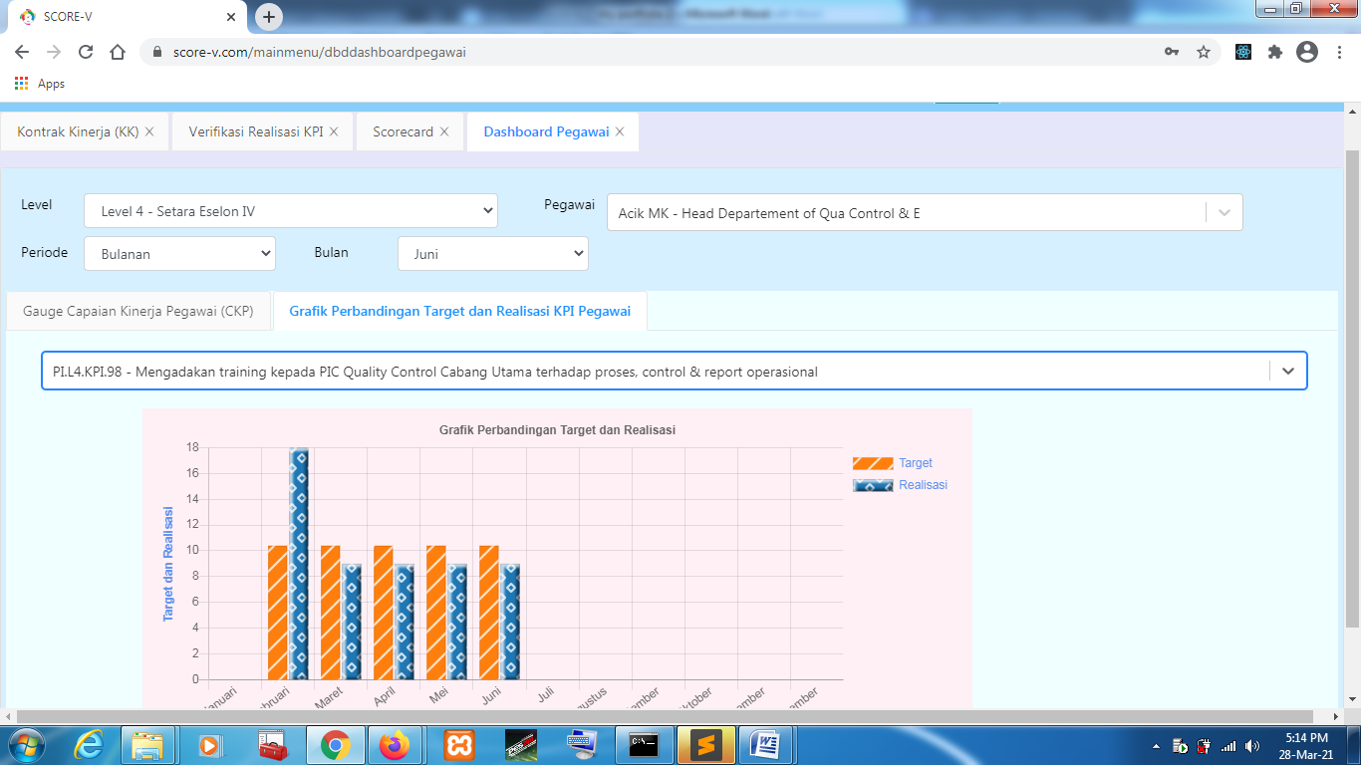

Figure

1. An example of reports that can be generated by this application is shown below (Figure 6) :

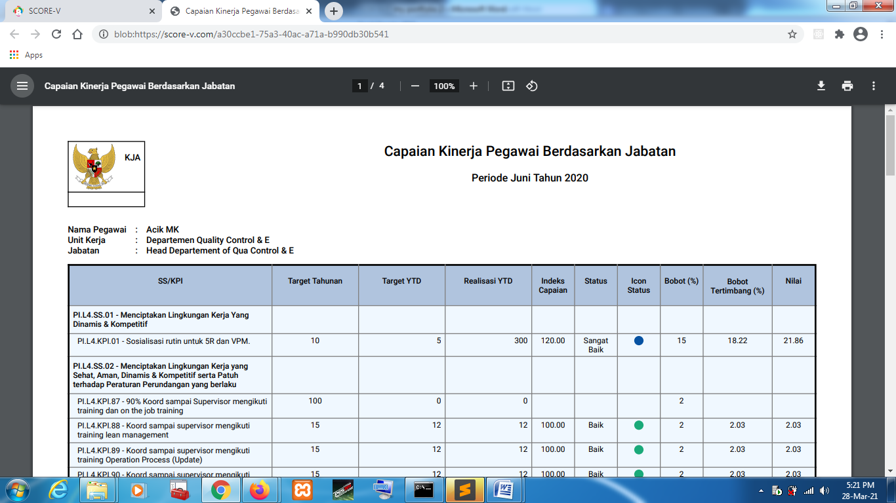

Figure